Salesforce work Day-2
Salesforce Apex Collections:
Block 1: Apex Collections
Introduction
Apex Collections are used to store multiple values or records in memory. Salesforce provides three main collection types:
- List
- Set
- Map
Each collection serves a different purpose depending on the business requirement.
1. List Collection
Description
A List stores multiple records in an ordered sequence. It allows duplicate values and is useful when all records need to be processed one by one.
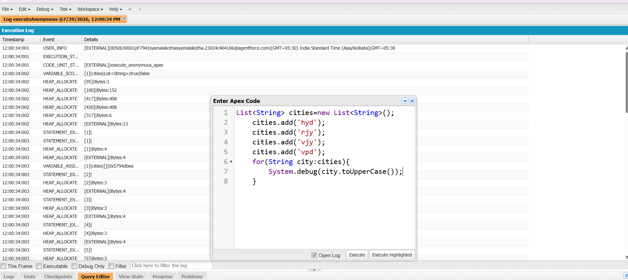
2. Set Collection
Description
A Set stores only unique values. Duplicate records are automatically removed.
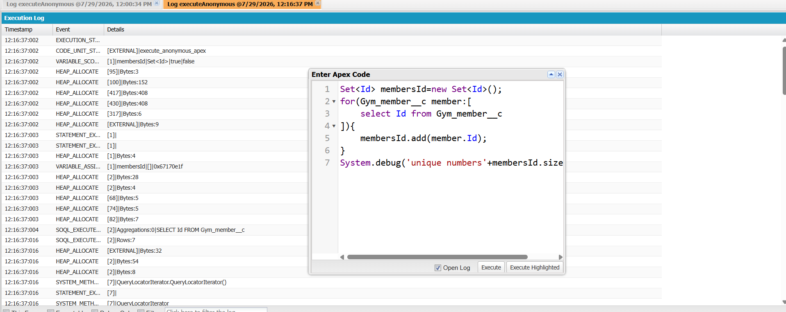
3. Map Collection
Description
A Map stores data as Key–Value pairs. In Salesforce, it is commonly used to quickly retrieve a record using its Id.
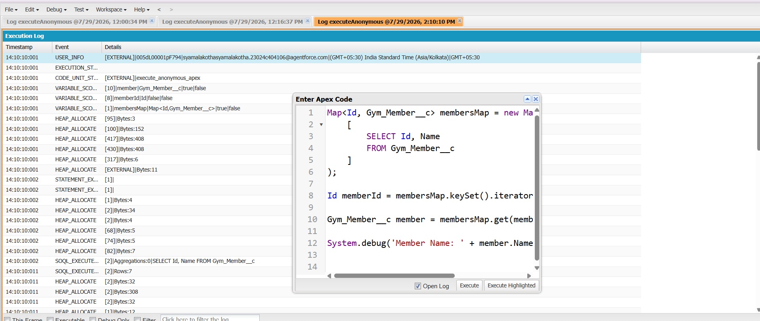
Block 2: Governor Limits
What are Governor Limits?
Governor Limits are restrictions imposed by Salesforce to ensure that no single Apex transaction consumes excessive resources. Since Salesforce is a multi-tenant platform, these limits help maintain performance and stability for all users.
What is Bulkification?
Bulkification is the process of writing Apex code that can handle multiple records efficiently in a single transaction.
Instead of processing one record at a time, the code processes all records together.

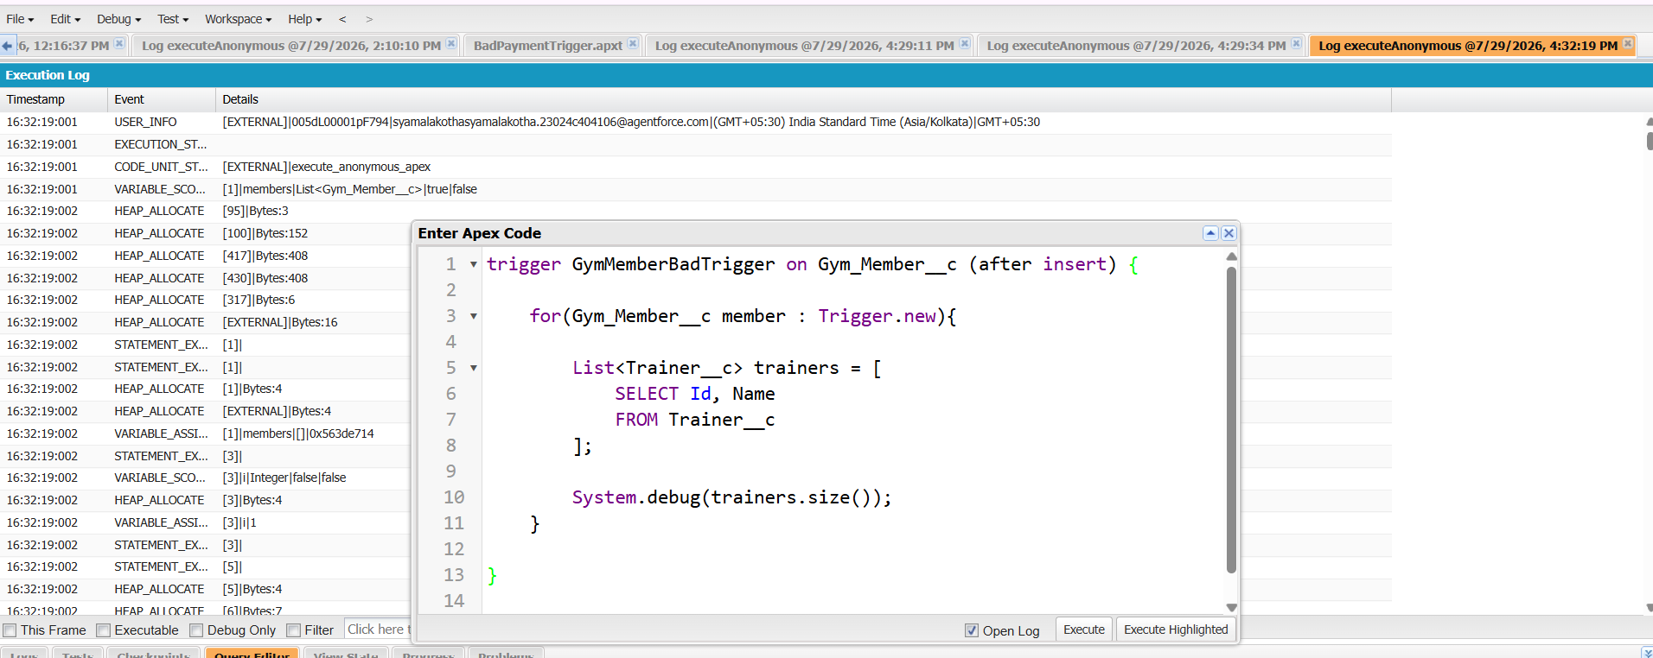
Expected Error:
System.LimitException:
Too many SOQL queries: 101
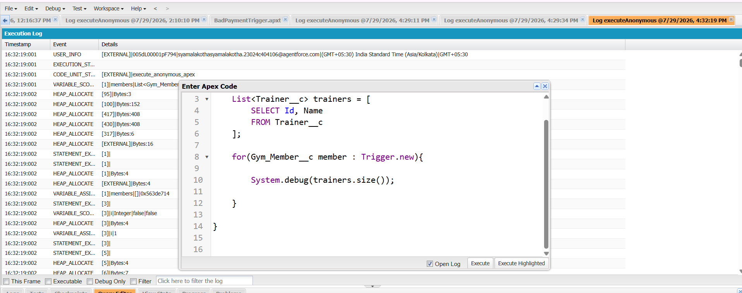
Block 3: Asynchronous Apex – Introduction
What is Asynchronous Apex?
Simple Definition
Normally, Apex code runs immediately. This is called Synchronous Apex.
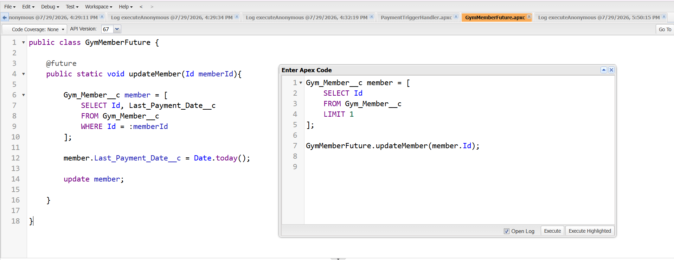
2. Queueable Apex
Queueable Apex is an improved version of Future Methods.
It allows:
- Complex objects
- Job chaining
- Better monitoring
3.Batch Apex
Batch Apex is an asynchronous Apex feature in Salesforce used to process large amounts of data that exceed normal governor limits. It divides large data sets into smaller batches and processes each batch separately.
Batch Apex implements the Database.Batchable interface and contains three main methods:
- start()
  - Used to collect the records that need to be processed.
  - Returns a QueryLocator or Iterable containing the records.
- execute()
  - Processes each batch of records.
  - The batch size can be defined while executing the batch.
- finish()
  - Executes after all batches are completed.
  - Used for sending notifications, performing cleanup operations, or starting another process.
- Scheduled Apex:
Scheduled Apex allows Apex classes to run automatically at a specific time or at regular intervals. It is used to automate recurring tasks without manual execution.
Scheduled Apex implements the Schedulable interface and contains the following method:
Drive Links:
https://docs.google.com/document/d/10EhlYD0GbowRlVDVWQReCqfonLYvRfgN/edit?usp=sharing&ouid=110754544831447835453&rtpof=true&sd=true -23PA1A4569 -K Kushal
https://docs.google.com/document/d/1IJgrNYip08Ov03cJvlMItvRxlInbD0TG/edit?usp=sharing&ouid=117213501334672229418&rtpof=true&sd=true -23PA1A0593-J Nikitha
https://docs.google.com/document/d/1v3ak75NQ-TAGfDCKrQjHaHVQa8tujzV1/edit?usp=sharing&ouid=105391221560152229827&rtpof=true&sd=true -23PA1A1269-G Vaibhav
https://docs.google.com/document/d/1VXCJ64zAsB8qgKkwyf-8zldamf3ZhCMk/edit?usp=drivesdk&ouid=101074113402474933429&rtpof=true&sd=true -23PA1A12A2-K Sruthi

